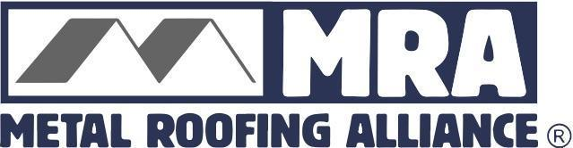

Contact: Darcie Meihoff, Metal Roofing Alliance (MRA), darcie@metalroofing.com or 971-998-3782

FOR IMMEDIATE RELEASE
July 26, 2021

“An indispensable tool that helps homeowners avoid a potentially massive mistake”
MRA’s free online visualizer tool gives homeowners the opportunity to try before they buy and invest thousands on a new roof

PORTLAND, Ore.—Re-roofing can be an intimidating process. It’s an investment that can cost tens of thousands of dollars, and yet when it comes to choosing the right color and style, homeowners typically have just a small selection of tiny material swatches to figure out what’s going to look best on their home.
“It’s hard to imagine even buying a pair of shoes without seeing them first, so how can homeowners be expected to choose a roof they may have to live with for as long as 50-plus years, without first even knowing how it’s going to look on their home?” said Renee Ramey, executive director of the Metal Roofing Alliance (MRA).
That conundrum is the reason the MRA offers one of the most robust online visualizers in the home improvement industry; a free tool that allows homeowners to upload a photo of their actual home and “try on” different styles, colors and metal roofing materials before making a re-roofing or new build decision. MRA recently expanded the visualizer with the latest updated metal roofing styles, including more color selections for stone-coated metal roofs in shake, multi-color, tile (low and high profile) designs. This adds to the visualizer’s already extensive library of roofing patterns, styles, material types and shades. The MRA visualizer tool can be found at www.metalroofing.com
The MRA visualizer is an essential resource, given the fact that quality metal roofs are proven to last nearly three times longer than other types and come in a wider variety of colors and styles than any other roofing material. That means homeowners have to live with their decision for a very long time, and must take into account a huge variety of potential choices. The visualizer is exceedingly simple to use, takes the guesswork out of the selection process and allows homeowners to do their pre-work prior to contacting a metal roofing installer.
“The visualizer gives homeowners the opportunity to ‘kick the tires’ when it comes to exploring the range of metal roofing choices that are out there,” said Ramey. “That’s key, because the right roof can add tremendous curb appeal and increase the value of a home, so doing that initial homework can definitely pay off in a major way.”
Homeowners who prefer the look of other roofing materials such as shake, tile, slate and even asphalt, are often surprised to learn that they can get metal roofing that mimics those styles, yet offers all the performance benefits, reliability, low maintenance and durability of metal. Metal roofing is more energy efficiency, resistant to wildfire danger and resilient against climate extremes such as severe storms, hail and hurricane force winds. Plus, unlike other material, metal is extremely strong but lighter weight, meaning additional roof structural support typically isn’t necessary and it can be 100 percent recycled at the end of its very long life, making it a more sustainable choice.
“Appearance and performance are very important when it comes to choosing the right roof,” said Ramey. “The visualizer helps give homeowners confidence they are making a smart decision.”
About Metal Roofing Alliance (MRA)
Representing the residential metal roofing industry in the United States and Canada, the Metal Roofing Alliance (MRA) was formed to help educate consumers about the many benefits of metal roofing. The main objective of MRA is to increase awareness of the beauty, durability, and money-saving advantages of quality metal roofing among homeowners, as well as to provide support to the residential metal roofing industry. For more information, visit MRA at www.metalroofing.com.
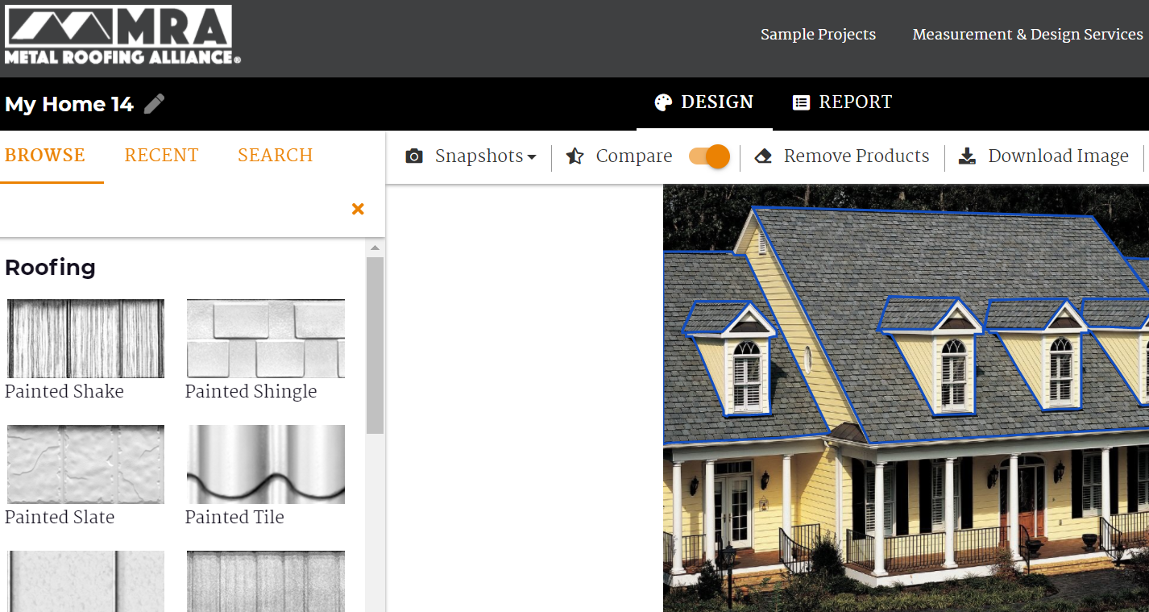

(Suggested photo caption: MRA’s free online visualizer tool at www.metalroofing.com offers lots of options to try on different metal roofing styles, colors and designs)

